**UNIX COMMANDS-5**

**Haripriya Kumar**

**Emp ID-6156**

**Batch-89**

SHELL SCRIPT

1. Create .sh file using any editor say gedit and enter the UNIX command in the file as follows

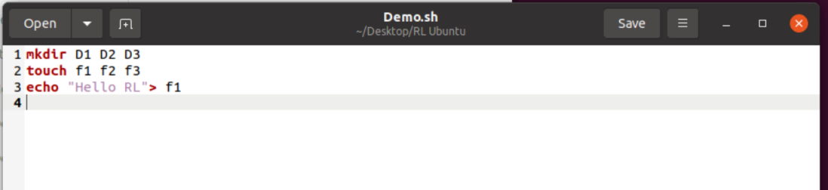

2. Execute .sh file using **./filename.sh** command. Its shows error that permission denied, so add execute permission to the file and execute

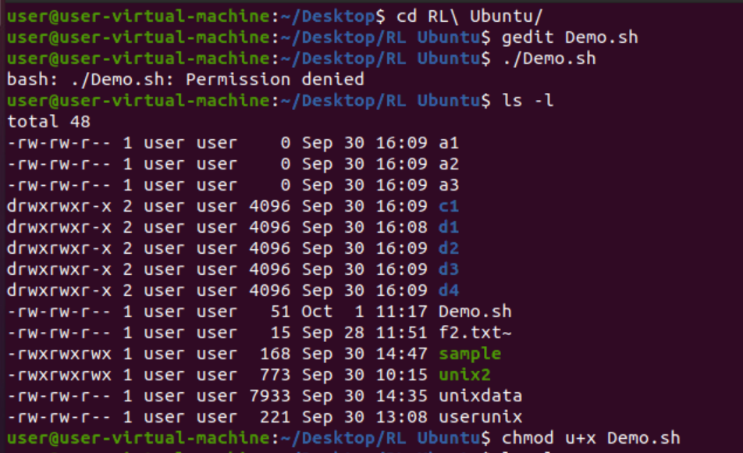

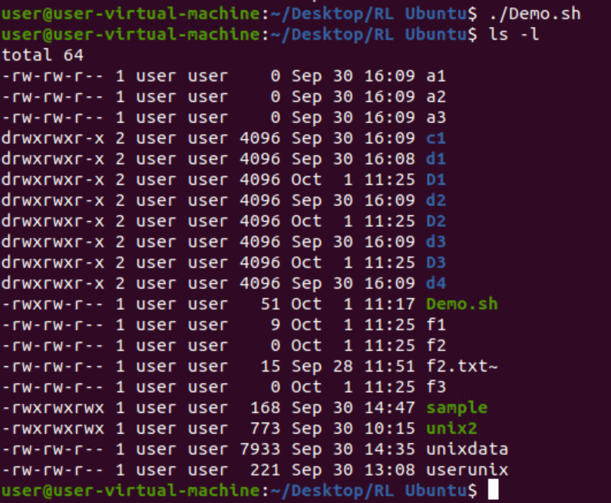

Write shell script for the following patterns

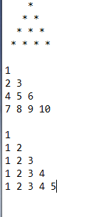

1.

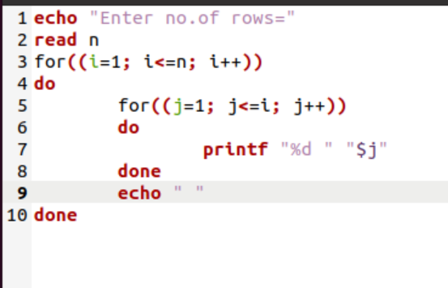 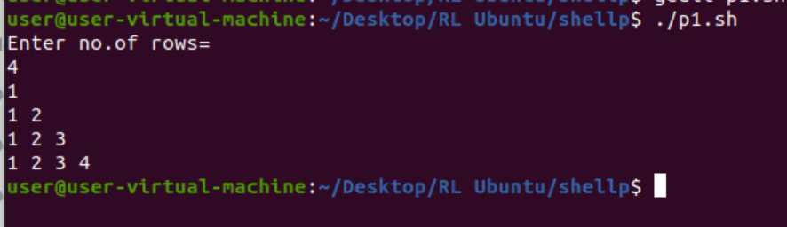

2.

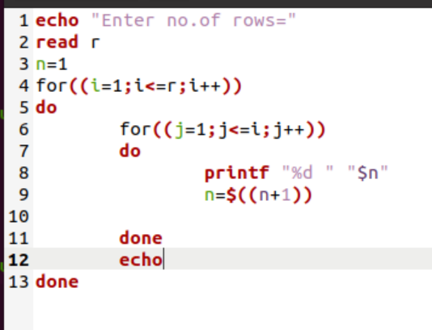

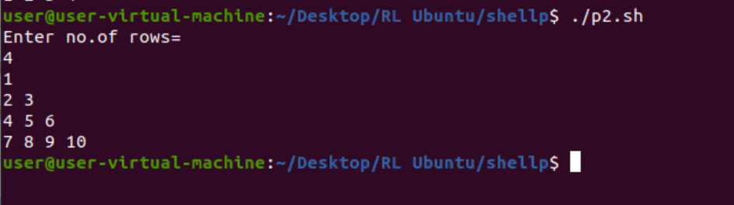

3.

